**FLIPKART Dataset Analysis and Prediction**

**Introduction**

* This Dataset contains information of Products Name, Price, Reviews, actual price and sale price. This dataset contains 14946 rows and 16 columns. Using Customer Review or Summary we can predict which give your idea about that product should be purchase or not based on Positive, Negative Reviews*.*
* Flipkart is one of the most popular Indian companies.
* India's biggest online store for Mobiles, Fashion (Clothes/Shoes), Electronics, Home Appliances, Books, Home, Furniture, Grocery, Jewellery, Sporting goods, ...
* It is an e-commerce platform that competes with popular e-commerce platforms like [Amazon.](https://www.amazon.com/)
* Product reviews and descriptions play a significant role in the e-commerce industry, particularly on platforms like Flipkart. They provide valuable information to potential customers, helping them make informed purchasing decisions.

**INSIGHTS:**

Exploring the distribution of prices

1. products are sold above 3.5 rating. That means if any product is new or unknown the product may don’t have ratings or views. By this rating we have benefits as well as has disadvantages.

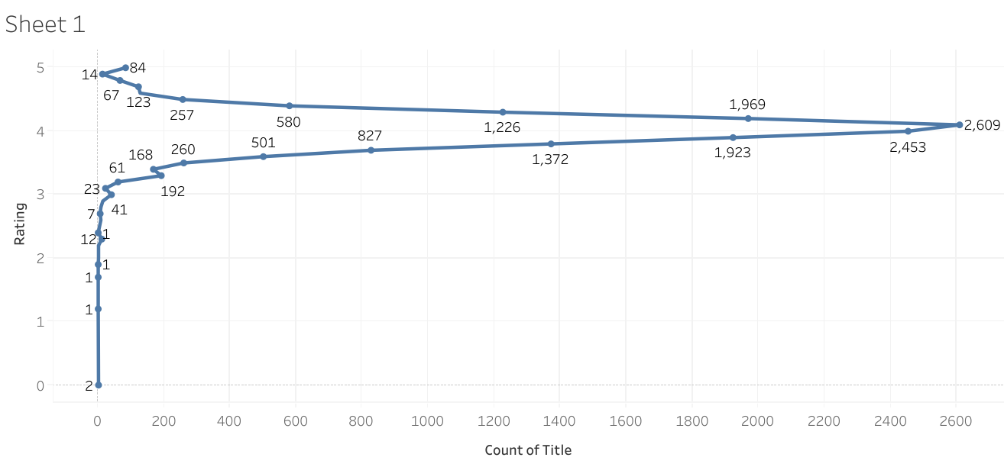

#### Products in the "Women" category have more "5.0" ratings than the other 2 categories. This may imply that Women shop more! Or other factors also, such as lack of good products in the other categories

#### 

#### Exploring the reviews:

#### Flipkart ratings has highest rating compared to the Amazon may be here flipkart and amazon has different user base or marketing shares in different regions. Some customers prefer one platform for specific types of products. Promotions, discounts can influence user rating and also higher no. of positive reviews can boost ratings for different platforms. Ratings may change overtime due to various factors.

#### Amazon VS Flipkart: A Detailed Comparison | All Perfect Stories

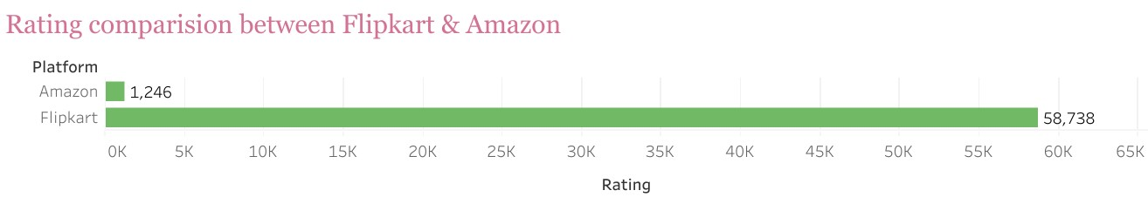

Obviously, women are shopping more and the reviews will get more from women only.

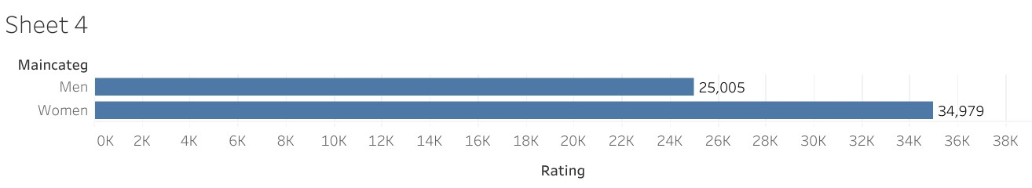

1. Flipcart will always announces offers and our customers will grab the offers every time. The opportunity. The customers are interested in some top 5 products like Flipflops, Slides, slippers, women sandals, it means whenever offers announces mostly women are shopping in that they are shopping especially footwears.

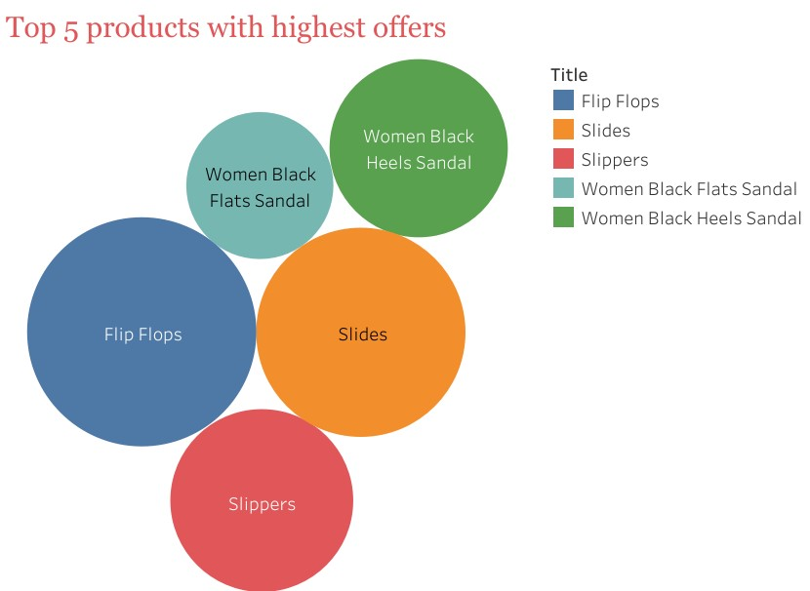

**Almost over 85 % discounts on the 5 items?????s How are the sellers making profits on these?**

1. The bottom 5 products 100% Comfort Extra soft Slippers for Women Flip Flops, Derby for Men, Slip on For Men, Synthetic Leather Casual Boots for Women and Girls Boots for Women Boots for Women, ® Premium Oxford Class Designer Patent Leatherette Shining Jet Black Lace-Up Party Formal Shoes Lace Up for Men these products has absolutely no offers may be there are not old stock or there are in good sale that’s why it doesn’t announced any offers on this least 5 products, we have many more which didn’t have in offer but the bottom 5 are these products.

#### Absolutely no offers on these products.

#### As per the data we have the customers are ordering from Flipkart mostly and also one thing women are purchasing more but they are didn’t giving rating to the products when compared to the men.

#### 

#### Correlation between offers & ratings, Whenever the offers will announces the sale of the products will increases, but the thing is the rating of ‘star 1’ is also increasing that means they are putting offers on old stock, outdated stock. The product is outdated that means quality of product will decreases, by this rating 1 & offers are “positivly correlated with each other ”.

#### 

#### By this correlation between shopping platforms, offers, rating. Amazon has low offers that means the cost of the product will be high but the rating is not bad, In Flipcart there are so many offers but the price is also high and the rating is normal by this correlation the flipcart has to improve the product quality.

#### 

#### Fulfilment category says that satisfaction of all requirements. Women has more portion in the chart than men, that means we can assume things. One is women shops more than men that’s why women has more fulfilment chart compared to men,

#### 

#### The top products with highest rating that means the product was in good quality and good price and the top 10 products are mostly women based only.

#### 

#### 

#### Most of the customers are likely to give these ratings like highest is 3.75 may be the most of the customers has average impression on the product that’s the average products have average rating. One more thing definilty the whole thing in a small thing makes big diference

#### 